# Introduction to Javascript

## Introduction to Programming with JavaScript

-n/a

## How is JavaScript used in the real world?

-n/a

## Introduction to programming

*The zeros and ones of binary code is a low-level language because it's closer to being understood by a CPU. JavaScript on the other hand is a high-level language. This means that it has to be converted to binary code so that a CPU can work with it.*

* *Yes*

## Why JavaScript?

*You are building a website using JavaScript. On which end of the site will JavaScript add interactivity to?*

* *Front-end*

## Programming in JavaScript

*JavaScript is integral to our everyday online experiences. Which of the following statements are true? Choose all that apply.*

* *JavaScript can provide a native feel to apps.*
* *JavaScript is used to power websites.*
* *Using JavaScript and React Native developers can create mobile apps.*

## Variables

*In JavaScript you can declare a variable with the keyword var. Which one of the following statements about var is correct?*

* *Var allows you to save a variable so that you can re-use it in future.*

## Data types

* String
* Number
* Boolean
* Null – The absence of a value
* Undefined – A variable not yet assigned a value
* Bigint – Accommodates a greater range of numbers
* Symbol – A data type used as a unique identifier

*Which of the following are examples of valid strings? Choose all that apply.*

* *'Hello world'*
* *"Hello world"*

## Operators

-n/a

## Writing statements

True or false: An if statement can be used to run code based on a condition being true.

* True

## Working with conditional statements

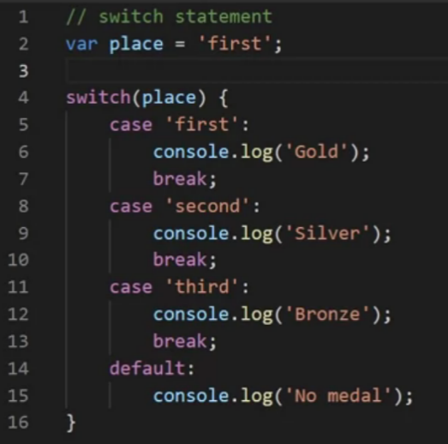

*You need to execute code based on a certain condition being either true or false. Which of the following types of statements can you use to complete this task? Select all that apply.*

* *A switch statement*
* *A conditional statement*

## Looping constructs

*You need to execute repeated blocks of JavaScript code until a certain condition is satisfied. Can you perform this action using loops?*

* *Yes*

## For loop

*How many lines will the loop below print in the console?*

*for (var i = 0; i <= 3; i++) {*

*console.log("This is line ", i)*

*}*

* *4*

## While loop

*True or false: A while loop will keep looping through a code block as long as a specified condition is true?*

* *True*

## Nested loops

However, you need to take care not to overdo it as multiple levels of nested loops are not very performant. In other words, the more nested loops there are, the slower your code will run.

*You are running multiple nested loops within your JavaScript code. Could these nested loops cause performance issues with your code?*

* *Yes*